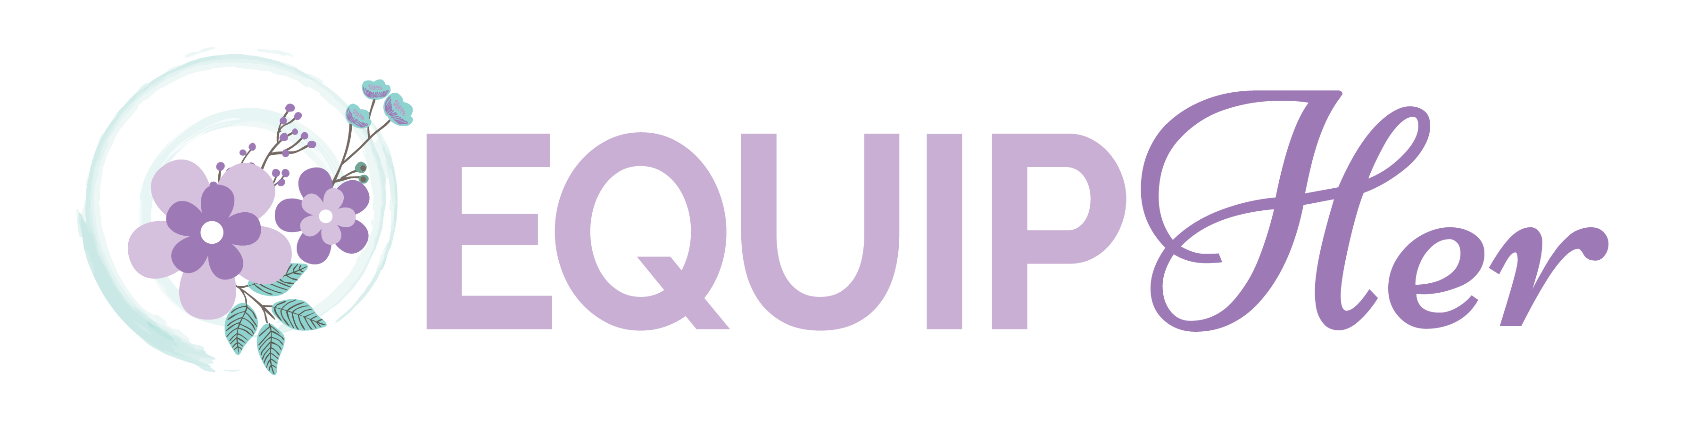
Media Release Form

I, _____________________________________________________________(please print), grant permission to EquipHer, Inc and its agents and employees the irrevocable and unrestricted right to reproduce the photographs and/or video images taken of me, or members of my family, for the purpose of publication, promotion, illustration, advertising, or trade, in any manner or in any medium. I hereby release EquipHer, Inc and its legal representatives for all claims and liability relating to said images or video. Furthermore, I grant permission to use my statements that were given during an interview with or without my name, for the purpose of advertising and publicity without restriction. I waive my right to any compensation.

I acknowledge that I am
[ ] over the age of 18
[ ] the legal guardian of the following

Name(s): ________________________________________________________________

Signature: _________________________________________Date: _________________

Address: ________________________________________________________________

If legal guardian, please list name(s) below:

